**Data Visualization using PowerBI Desktop**

Final Excel File after executing Python Code.

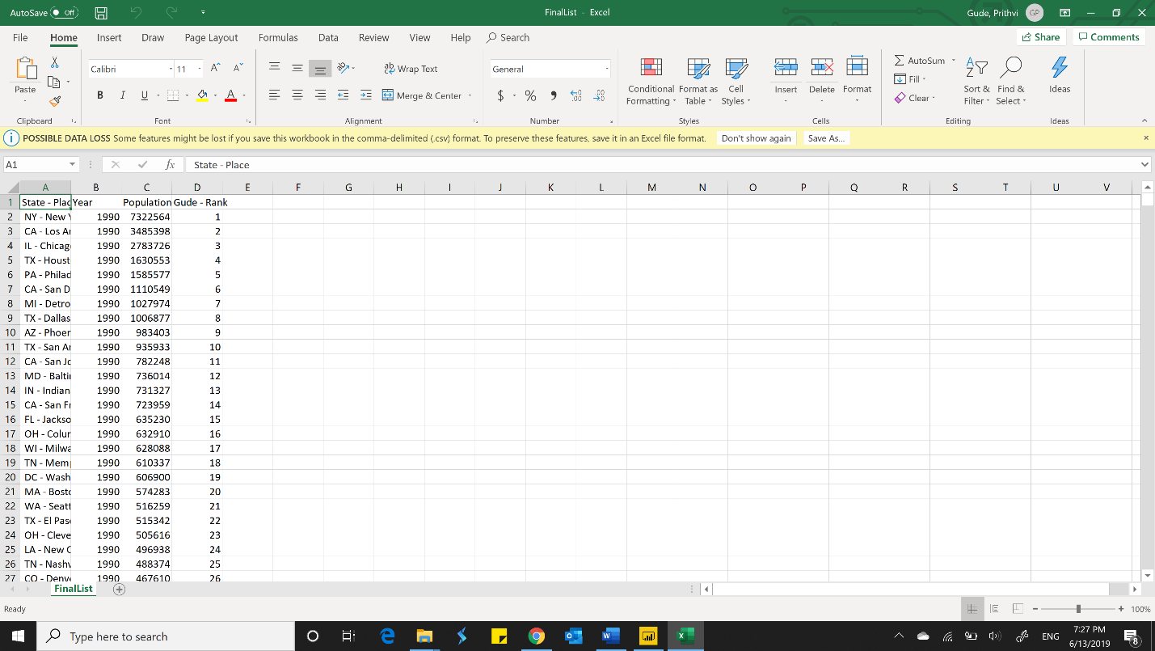

Data loaded in Power BI

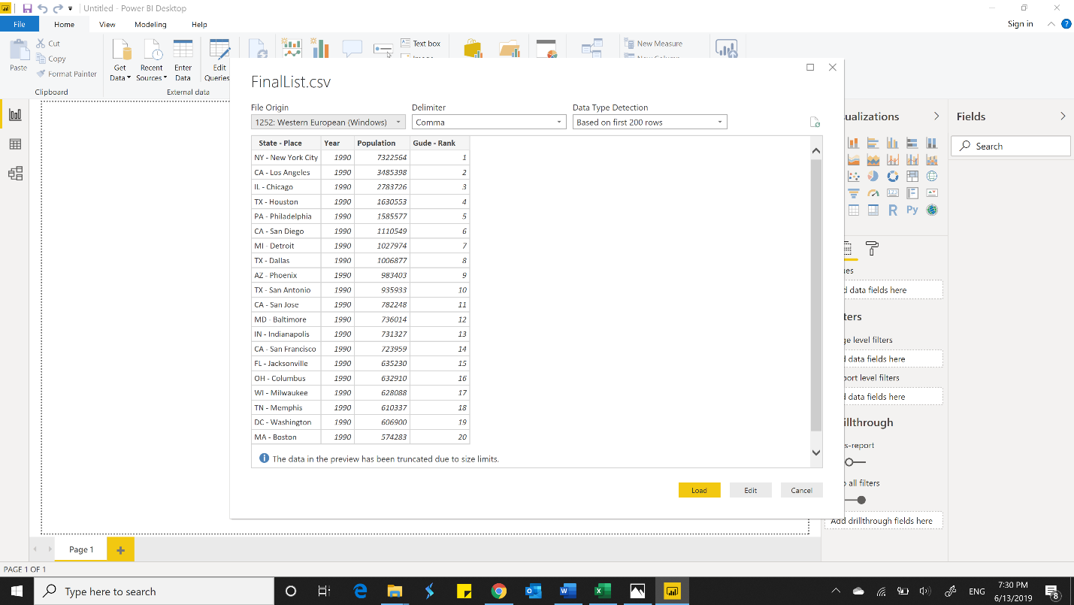

Rank Slider

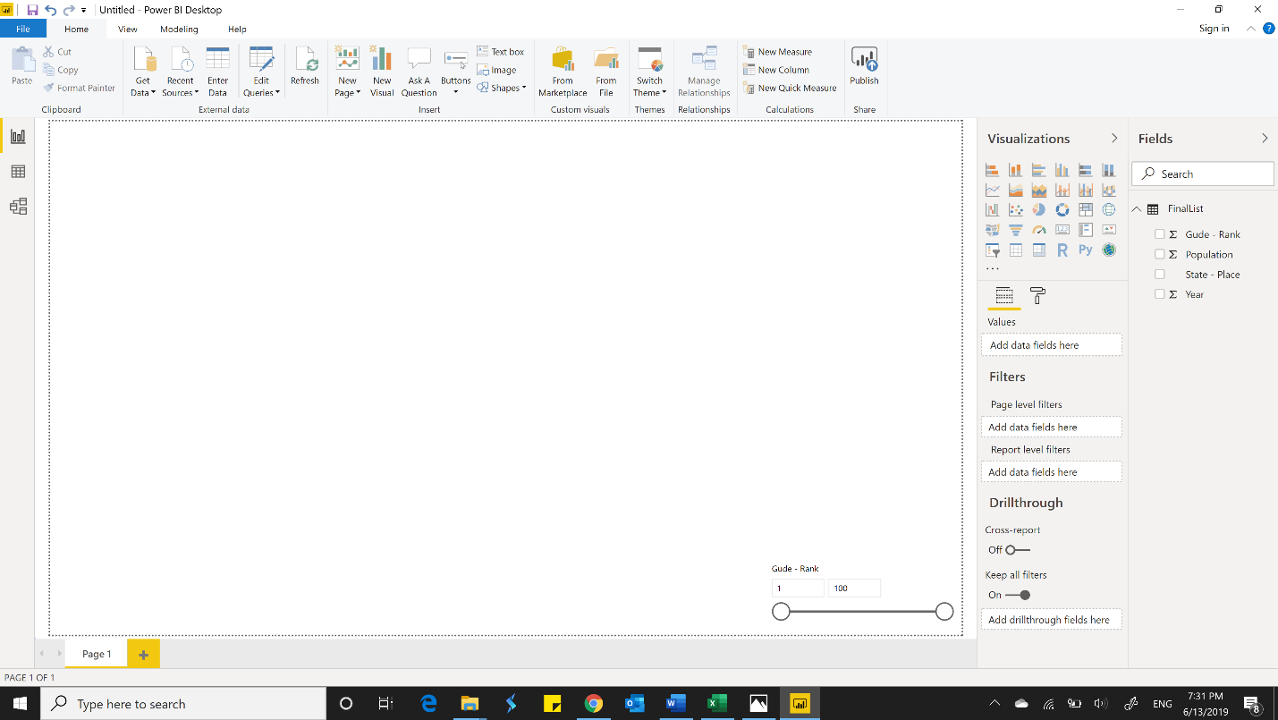

Newly created measure – Workforce (Highlighted in the screenshot)

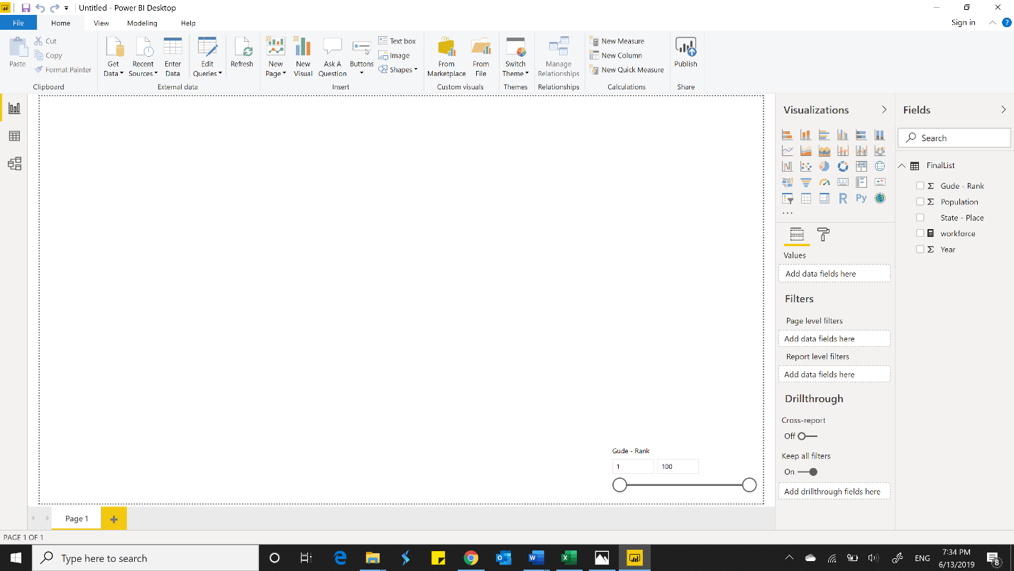

Scatter chart of the data Latest_cities

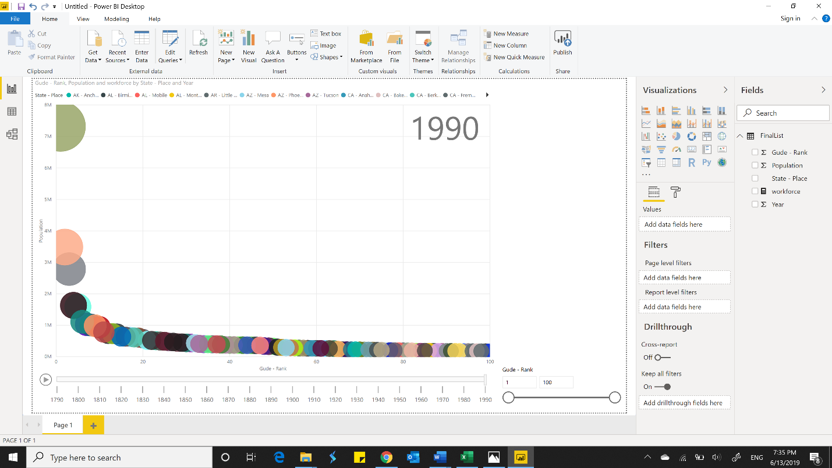

Screenshot with 5 Ranks

